**Interaction design on the web: an analysis of Temu**

Temu has been a recent topic of discussion in the South African space. It’s marketed as an incredibly cheap alternative to Amazon. On the surface, it seems to be a good idea; It’s a competitor that allows access to a huge inventory of goods for people living in poorer countries. Important to note though, is the fact that it is a dropshipping business that likely engages in sweatshop labour, if not worse. However, in this essay, I will be analysing the choices made by Temu with regards to their UI and interaction design, how they represent prices, and how their website design is made to drive sales no matter the quality.

For the first part of this essay, I have opened an incognito browser version of Temu, to simulate a user’s first experience opening the website.

Figure 1: The Temu Homepage

The first thing to notice in the home page is colour choice. The website is very bright, with the predominant colour being a warm yellow. Although not exactly the same colour as in research, it has been shown in a study conducted in Tilburg University that online shoppers present a statistically significant increase in likelihood to buy products with yellow as a background colour over red. (Broeder & Scherp, 2017) Practically, this means that the choice to have the website’s primary colour be yellow is both intentional and significant. By using this colour, Temu is pushing users to buy more products more frequently.

On the topic of time, the next thing to discuss is Temu’s timed deals. Just on this one screenshot, there is a very noticeable amount of urgent, timed offers. Free shipping, but only for now. All of these lightning deals, but only for now. Everything is available now. In other sessions, there are promises of huge discounts, but only if the user will buy the item within a very small period. This is all a contribution towards inducing impulse buying within customers. Cheap, low involvement products are correlated with more impulse buying from consumers (Zhao, et al., 2019), and adding a time limit to purchasing them spurs bad purchasing decisions even more.

Moving deeper into the site, I want to examine a listing for a random item on offer to see what practices are being used and the ethics involved in them.

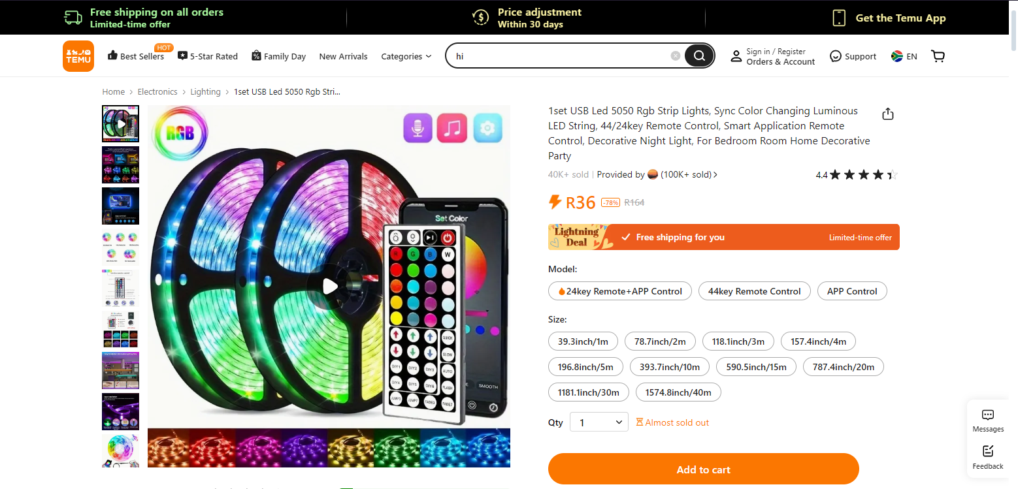

Figure 2: A listing on Temu

Here is a random listing from Temu when you click on an item. Once again, we see tons of usage of the red-yellow colour scheme from before, which again is very effective to push for impulse buying. Another common tactic introduced here is showing the user exactly how much of a discount they’re getting. Interestingly, the site shows both the previous amount and the percentage discounted. I think it’s a derivative of the rule of 100 (Berger, 2013). As described in his book, the rule of 100 states that for items over 100 dollars, you display a percentage discount, but for those under 100 dollars, you display an amount instead. This is so that the customer always feels as if they’re getting as large a discount as possible. Displayed here, however, is a synthesis of both approaches. By showing both the previous price and the percentage discounted, users feel as if they’re saving a lot of money, even in cases where the discount is low or unnecessary.

If a person does go through and add a few things to their cart, they will be pushed to a new screen for review and payment.

Figure 3:Temu's cart and checkout page

This page exemplifies all the dark design patterns that were discussed previously. Again, we can identify a few places where timing and urgency are utilized to push the user towards impulse buying, namely beneath the orders themselves, at the top of the page, and right above the big, bold checkout button. Important to notice here is that this page is far less busy than the rest of the site. The only attention-grabbing element on this page is the checkout button, a choice intentionally made by Temu to draw the user’s eye. All of the outrageous discounts that were seen before are added up in the order summary, leading to an impression of saving vast sums of money even when the practical cost of the items is still the same.

After looking at these pages, the question that needs to be asked is clear. What are the design goals of Temu, how are they achieved and are they ethical in how they have decided to do so?

The design goal of Temu seems obvious. They are chasing the profit motive that is inherently established within a capitalist system. More specific to them, though, we can see that they’re targeting people of poorer backgrounds, offering unbelievably low prices for products that should cost a lot more. According to an article in Wired, Temu is haemorrhaging money in their attempts to break into this market (Liu, 2023). In attempting to staunch these losses, they make use of common sales funnel tactics in order to lead consumers to spending more money than they planned to and buying things they don’t need. This is achieved by creating a sense of urgency through timed deals and large discounts. Certain important elements for commerce are emphasised while quality control and customer satisfaction are less important.

Finally, we must address whether this is an ethical strategy to employ. As it is a matter of ethics, my opinion will be more subjective than the rest of this essay, but I still think it’s an important discussion to have. In a nutshell, no, I don’t think that what Temu does is ethical, purely from the standpoint of UI and UX design. In nearly every instance, they employ dark design patterns to maximise every cent they can get out of consumers. I have heard from users of the app that there are wheel spins, invite specials and one-click purchasing that I have not been able to analyse in this essay. All these things are predicated on pulling current users further into the funnel and drawing new users in with empty promises or cheap specials. In the future, I predict that Temu will attempt to recoup their losses in similarly unethical ways, as the framework for user exploitation already exists. By adding shipping costs or raising the cost of their stock, they can leverage their captive market to generate huge profits.

In conclusion, Temu has designed a website that intentionally generates a captive audience. Through the use of bright colours, limited time deals, and algorithmic targeting, they cause users to pay far more than they expected for things that they don’t need.

# Bibliography

Berger, J., 2013. *Contagious: Why things catch on.* 1st ed. New York: Simon & Schuster Paperbacks.

Broeder, P. & Scherp, E., 2017. Colour preference of online consumers: a cross-cultural perspective. *Marketing from Information to Decision Journal,* 1(1), pp. 53-62.

Liu, T. W., 2023. *Temu Is Losing Millions Of Dollars to Send You Cheap Socks.* [Online]   
Available at: https://www.wired.com/story/temu-is-losing-millions-of-dollars-to-send-you-cheap-socks/  
[Accessed 5 April 2023].

Zhao, Z., Du, X., Liang, F. & Zhu, X., 2019. Effect of product type and time pressure on consumers’ online impulse buying intention. *Journal of Contemporary Marketing Science,* 2(2), pp. 137-154.